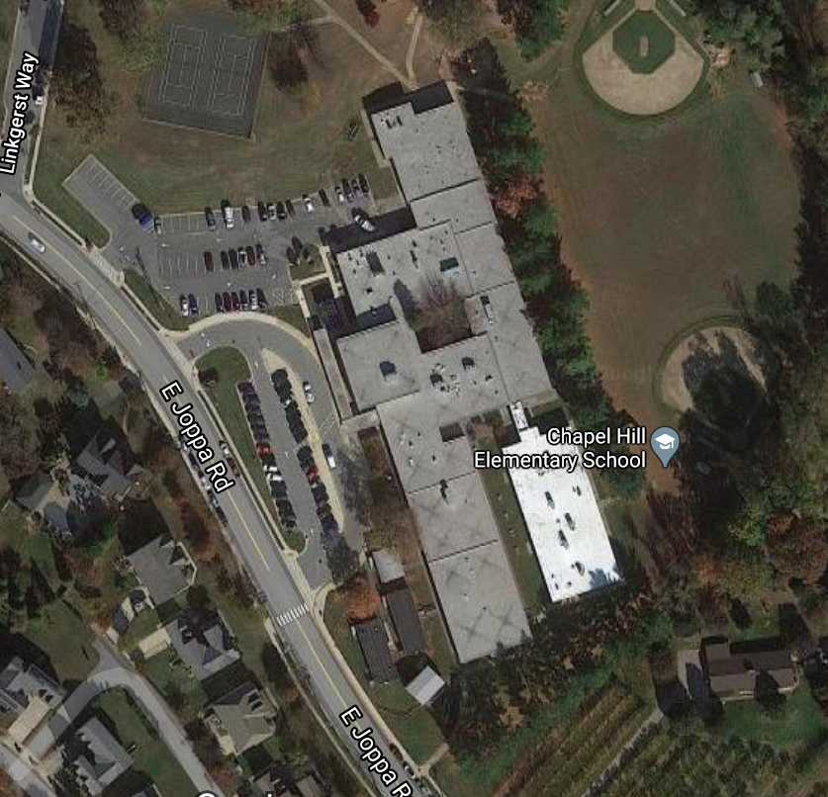

**Walkers**

Line up outside 2/3 classrooms. Wait with Staff Member to enter building.

**Parents will remain in their car.**

**A staff member will guide your student to assigned location.**

**Bus Riders**

Arrive and Dismiss from here

Gym Doors

**Chapel Hill Elementary**

Arrival and Dismissal Locations

**Car Riders**

Students will wait here to enter building after being dropped off.

Enter through side door.

**Car Riders**

Follow through side parking lot.